APPENDIX A
Infrastructure Photographs
Table of Contents
Page
Oxbow Powerhouse Photograph 1
Ralston Afterbay Dam Photographs 2
Ralston - Oxbow Tunnel Inlet Structure Photograph 3
Ralston Powerhouse Photographs 4
Middle Fork - Ralston Tunnel Inlet Structure Photograph 5
Interbay Low Level Outlet Photograph 6
Middle Fork Interbay Dam Photographs 7
Middle Fork Powerhouse Photograph 8
French Meadows Dam Outlet Works Photographs 9
French Meadows - Hell Hole Tunnel Intake Photograph 10
French Meadows Powerhouse Photograph 11
Hell Hole Dam Outlet Works Photographs 12
Hell Hole - Middle Fork Tunnel Intake Photograph 13
North Fork Long Canyon Diversion Dam Photographs 14
South Fork Long Canyon Diversion Dam Photographs 15
Duncan Creek Diversion Dam Photographs 16
Duncan Creek - Middle Fork Intake and Trash Rack Photograph 17

Ralston Afterbay

Oxbow Powerhouse Photograph

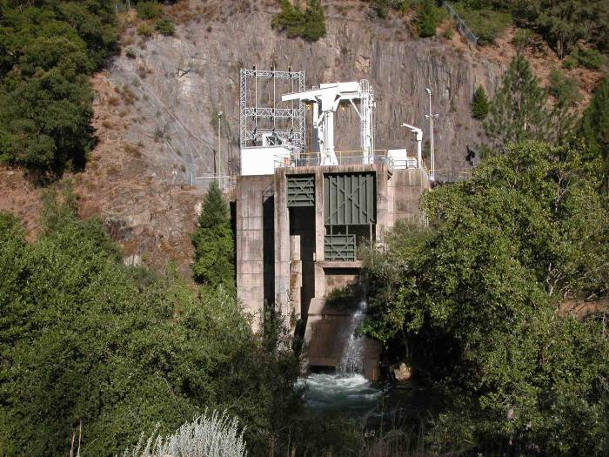
Oxbow Powerhouse
Ralston Afterbay

Ralston Afterbay Dam Photographs

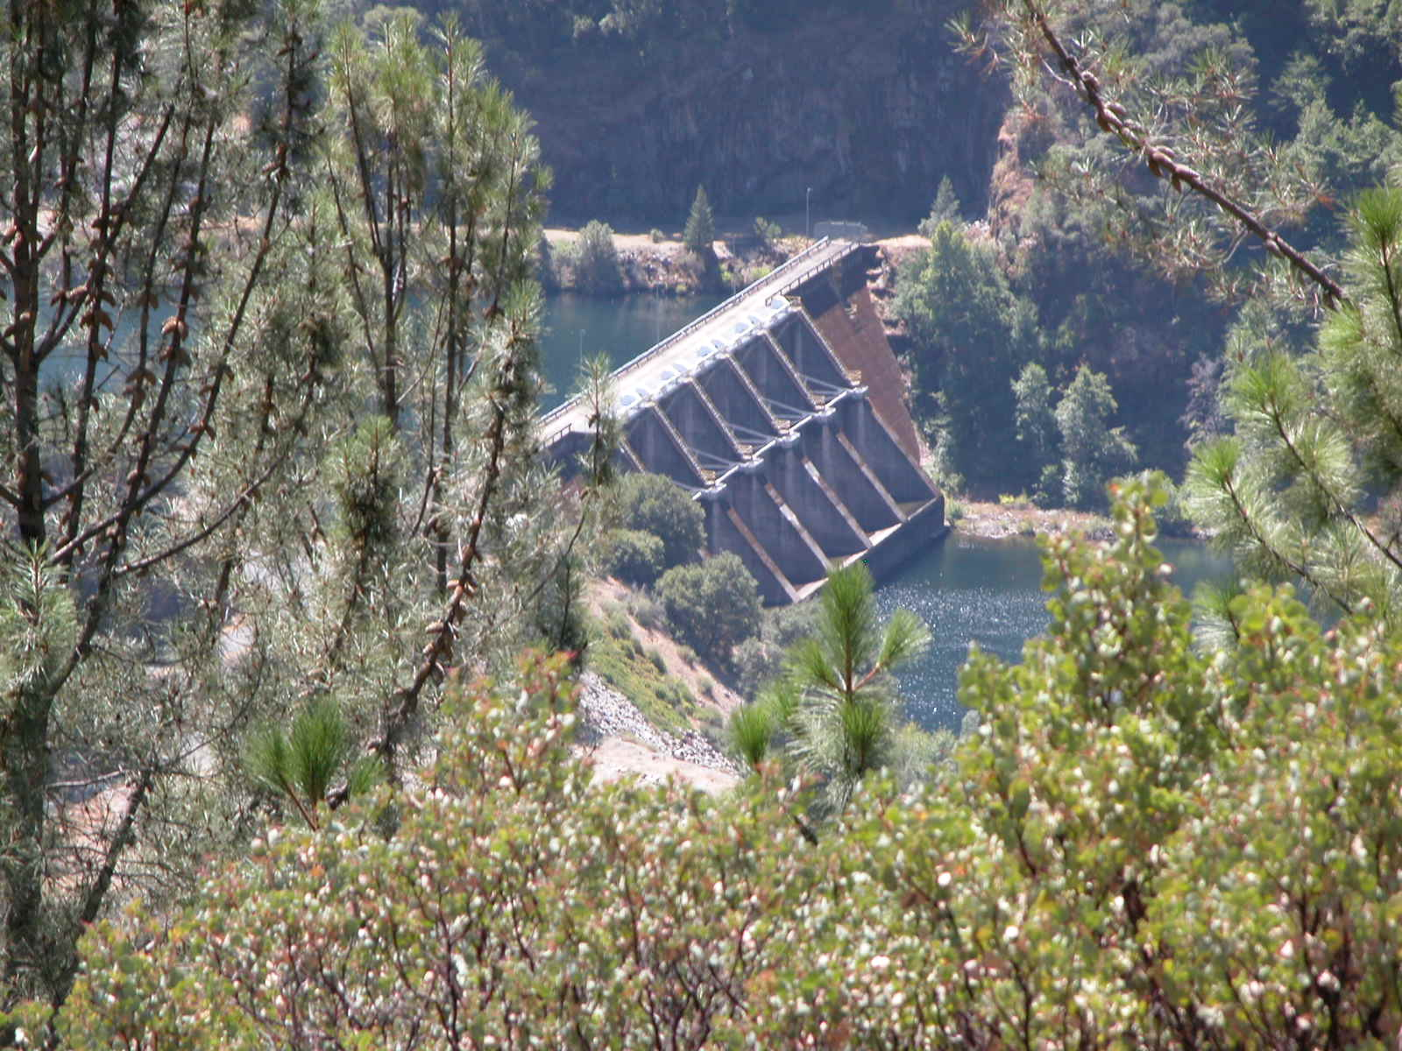

Ralston Afterbay Dam

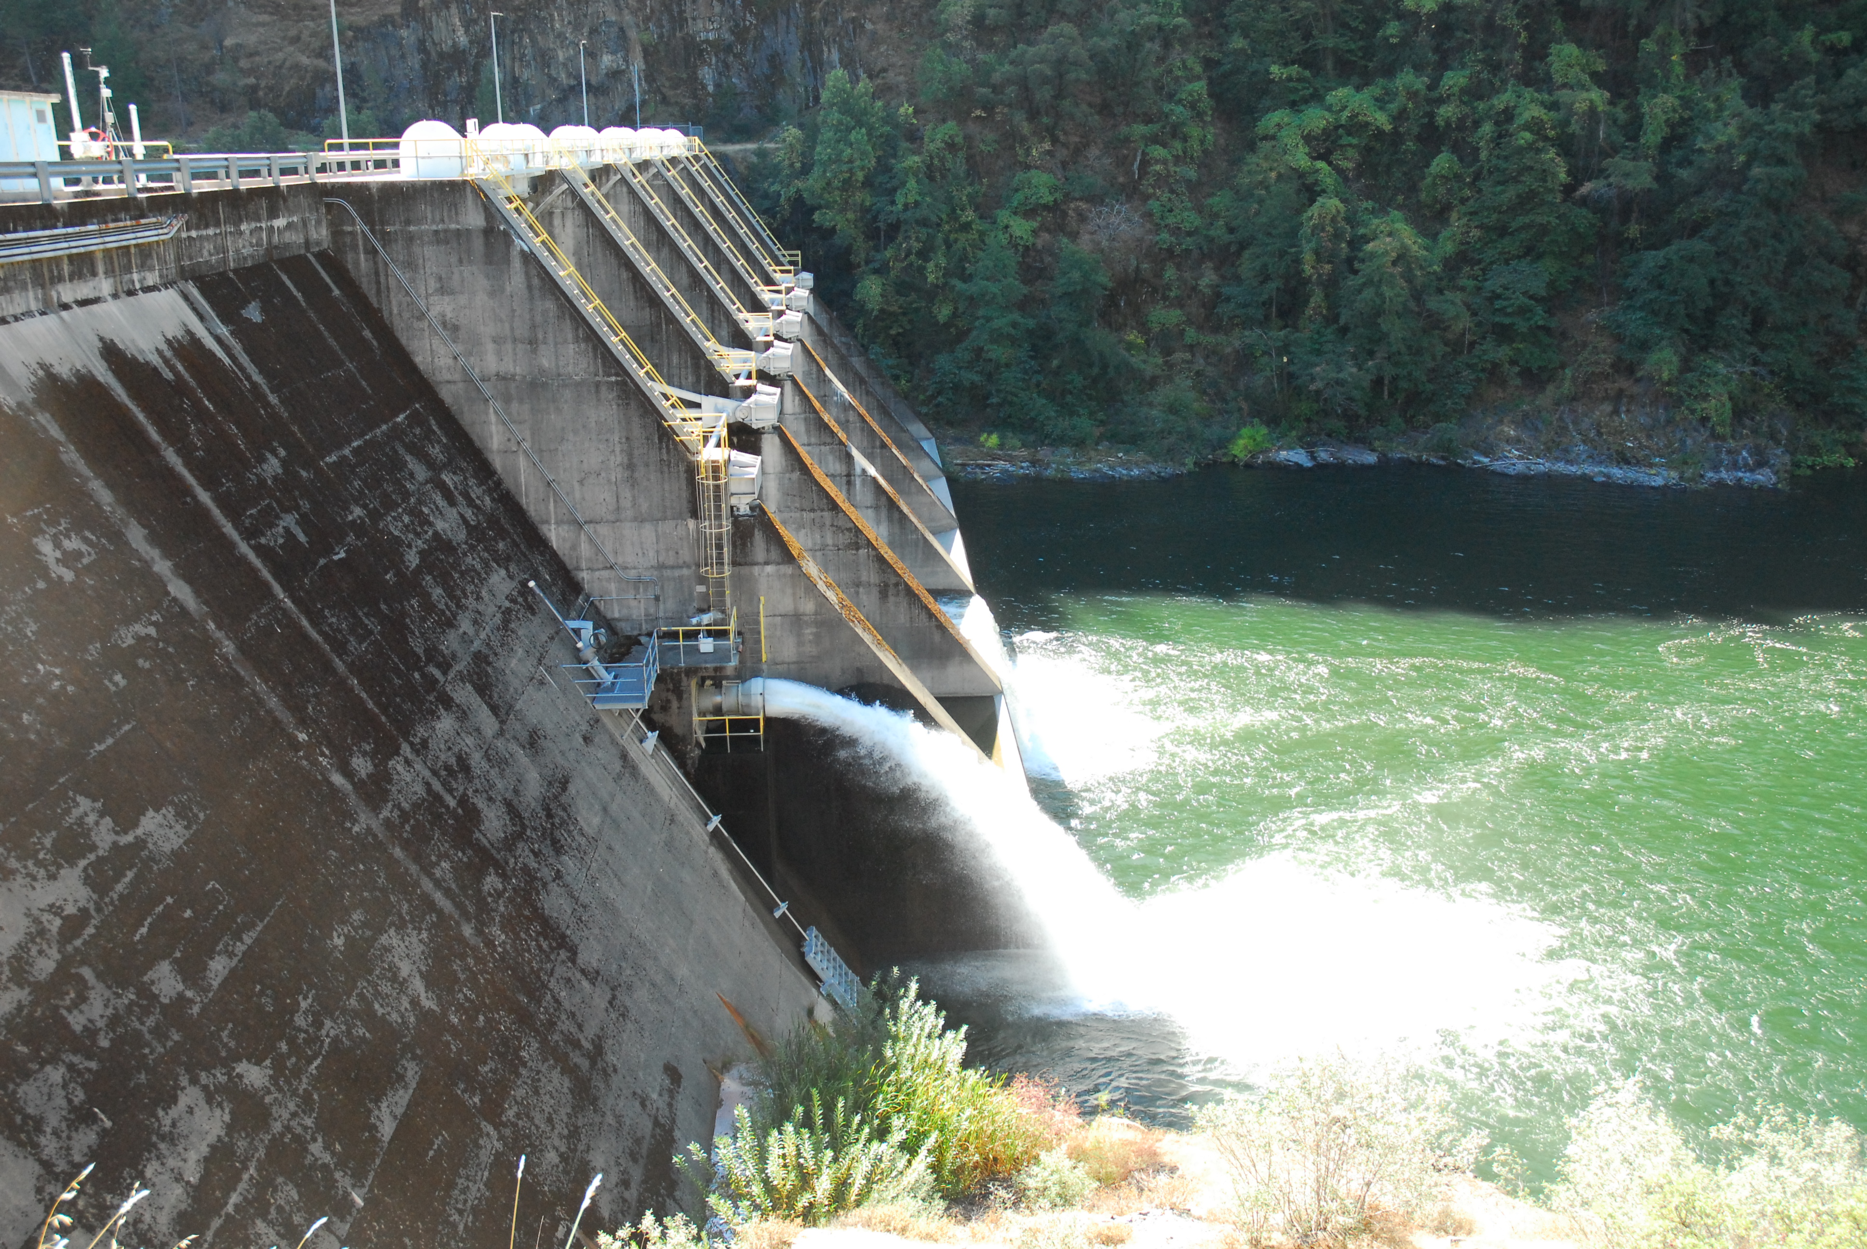
Instream Flow Discharge
Low Level Outlet

Ralston Afterbay Dam - Downstream Side

Instream Flow Discharge
Low Level Outlet
Ralston Afterbay Dam - Down Stream Side

Ralston Afterbay

Ralston - Oxbow Tunnel Inlet Structure Photograph

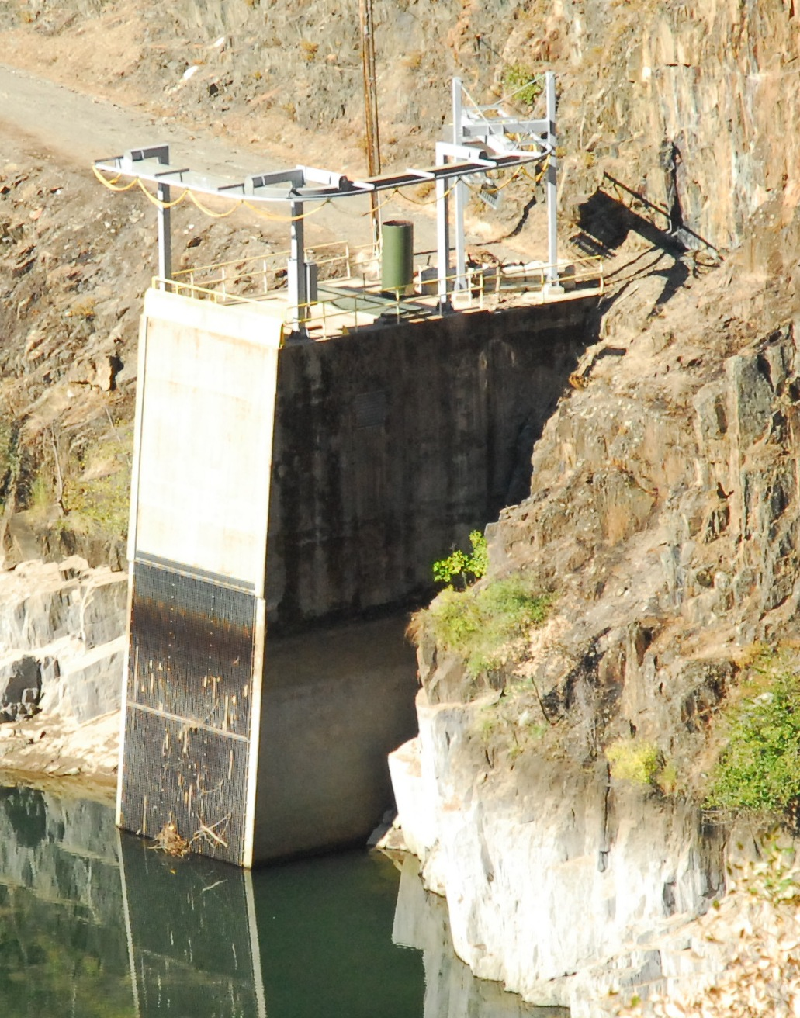
Intake Inlet and Trash Rack
Ralston-Oxbow Tunnel Inlet Structure

Ralston Afterbay

Ralston Powerhouse Photographs

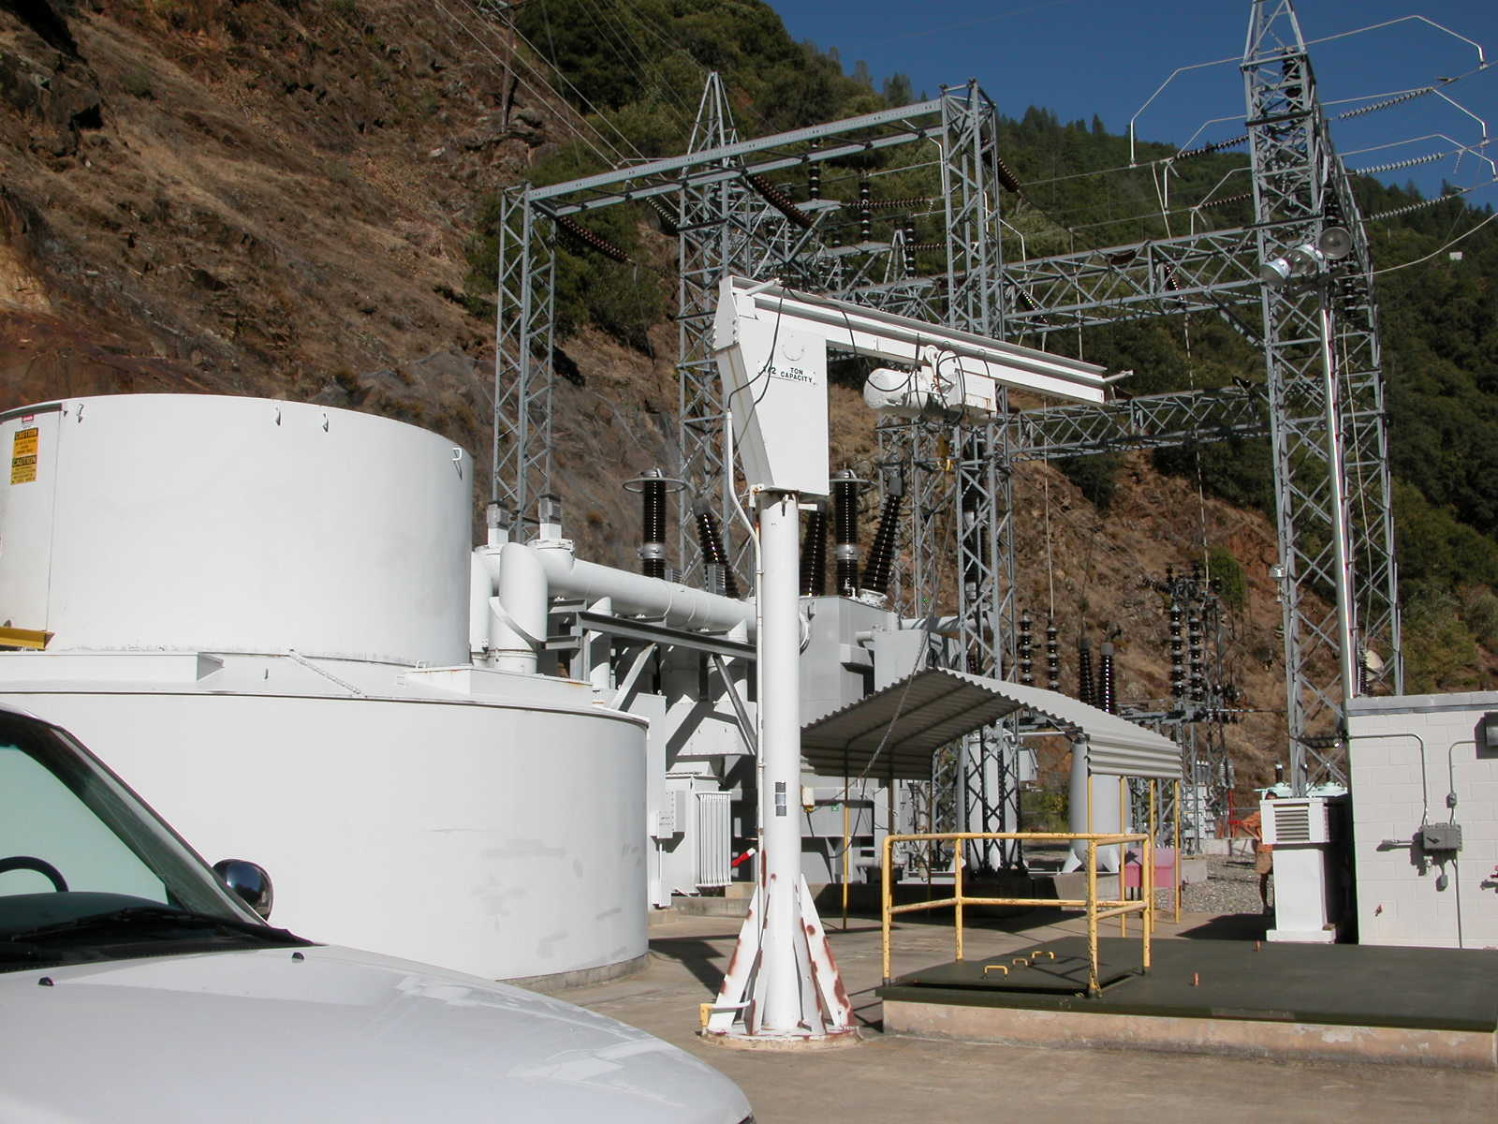
Ralston Powerhouse
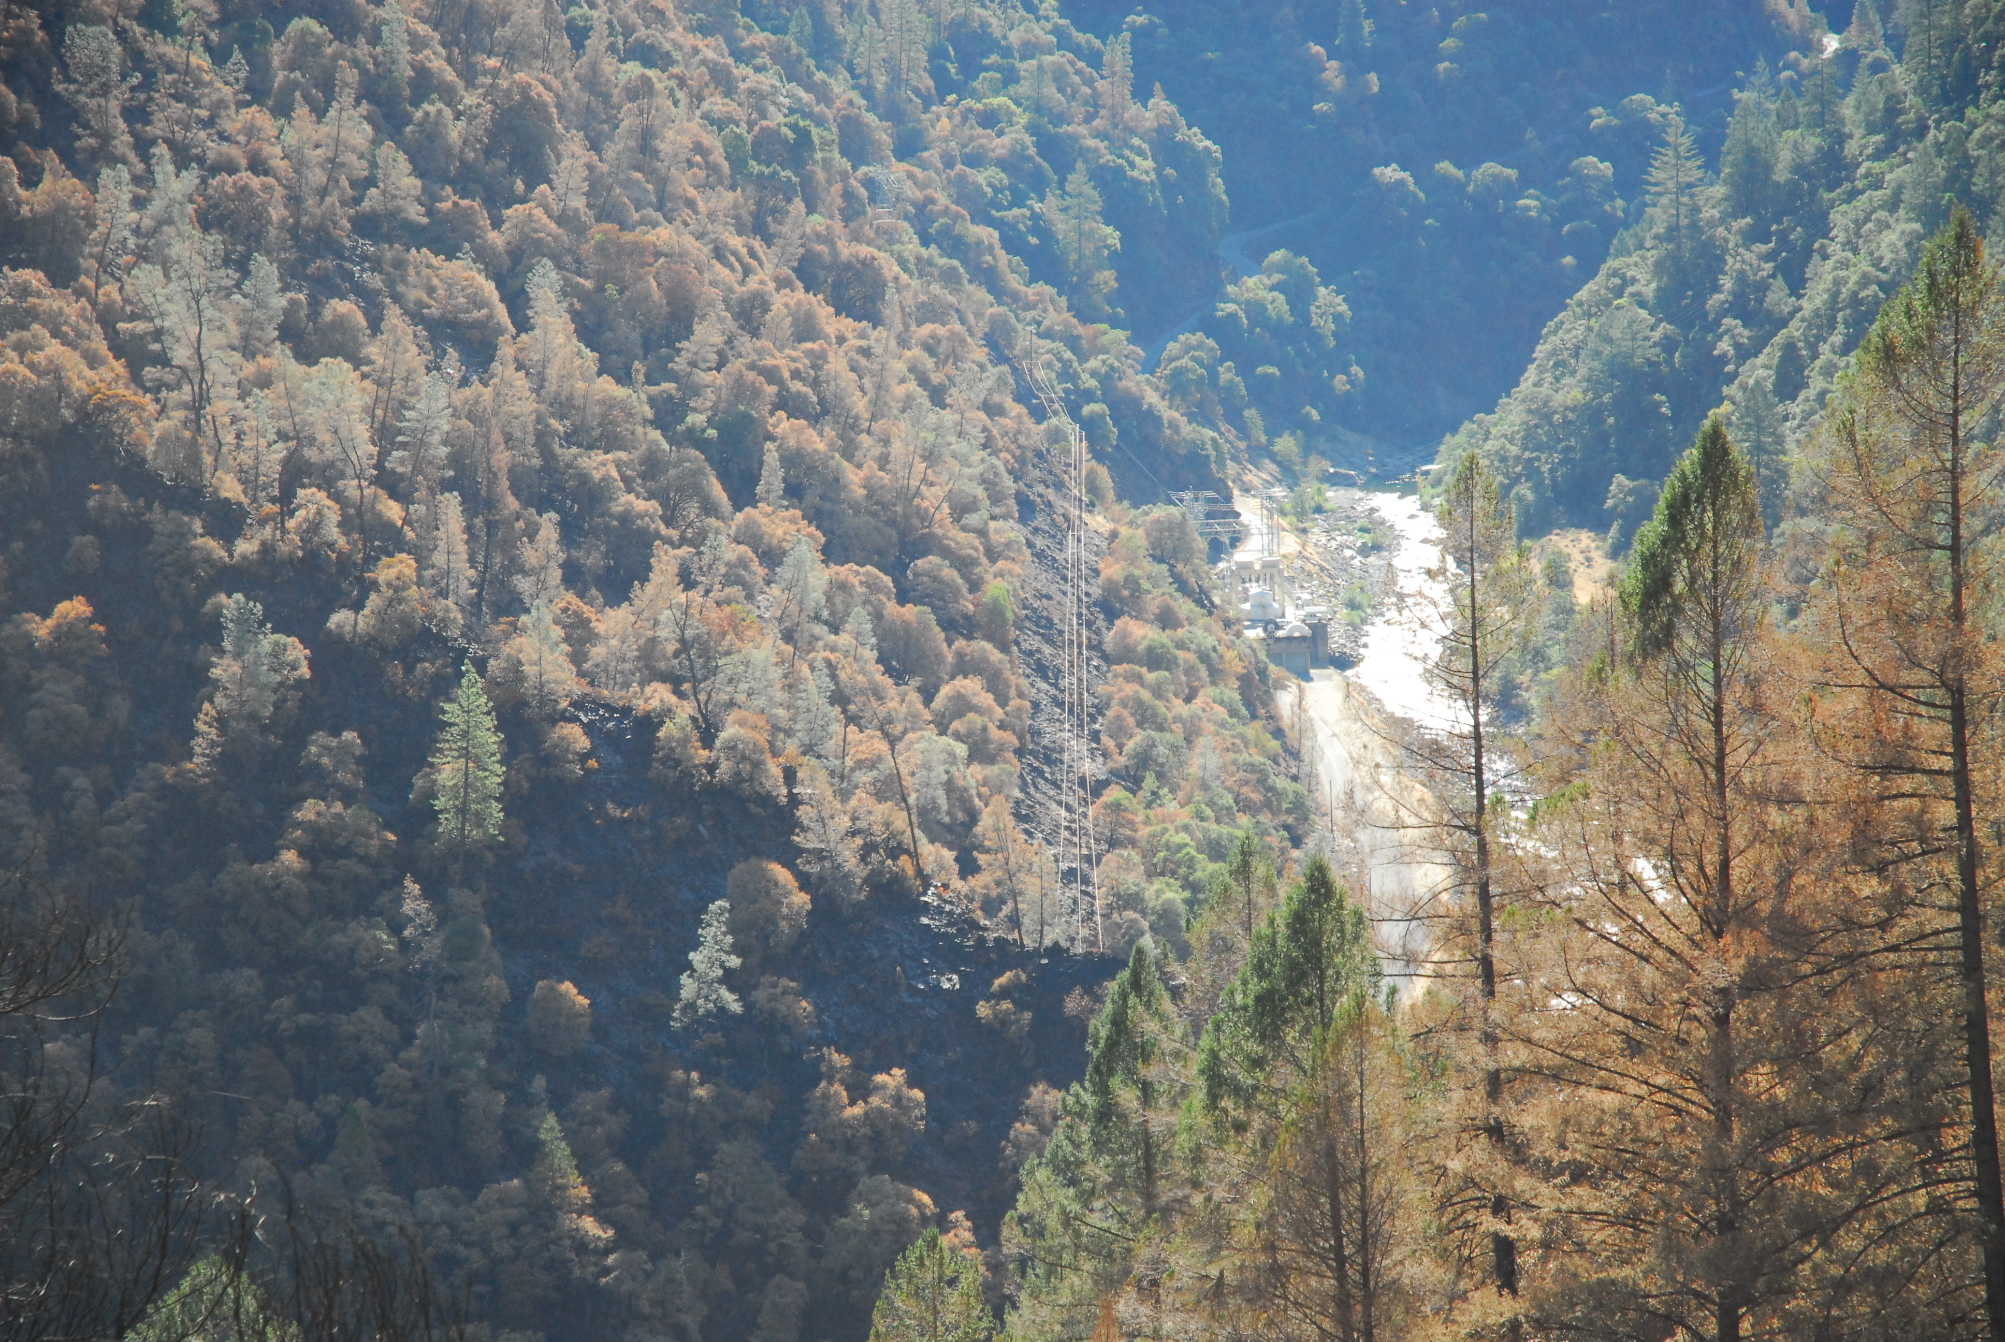
Ralston Powerhouse with Low Water Level

Middle Fork Interbay

Middle Fork - Ralston Tunnel Inlet Structure Photograph

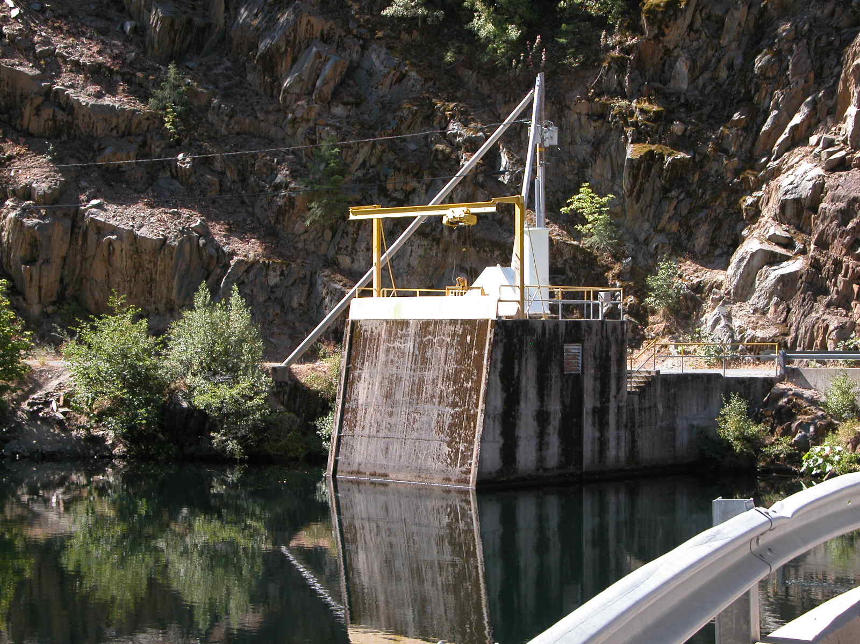
Middle Fork - Ralston Tunnel Inlet Structure

Middle Fork Interbay

Interbay Low Level Outlet Photograph

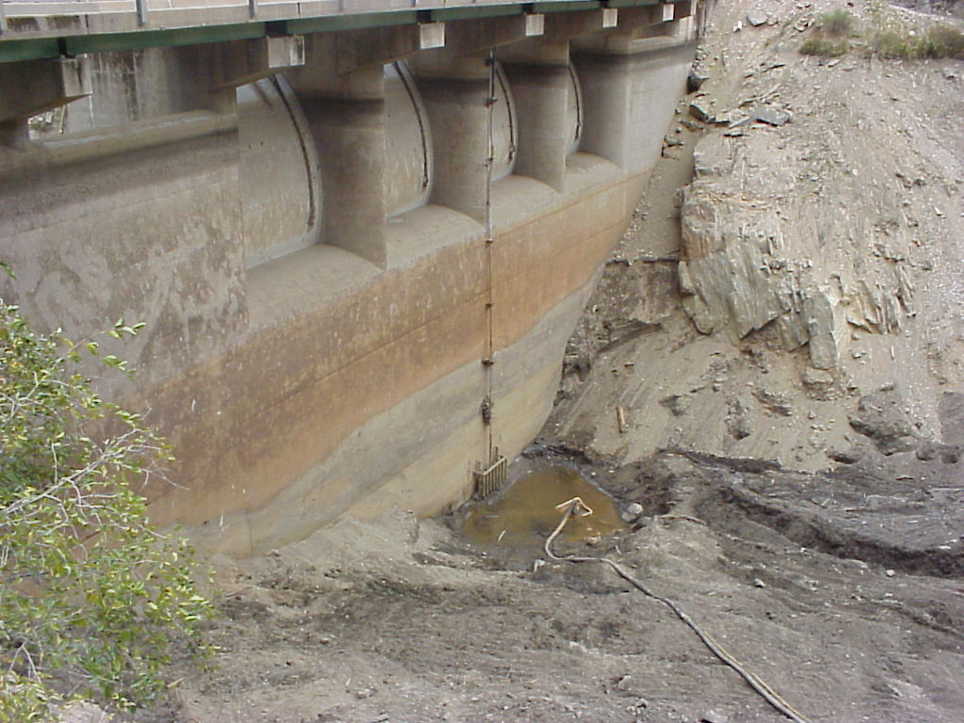
Interbay Low Level Outlet
Middle Fork Interbay

Middle Fork Interbay Dam Photographs
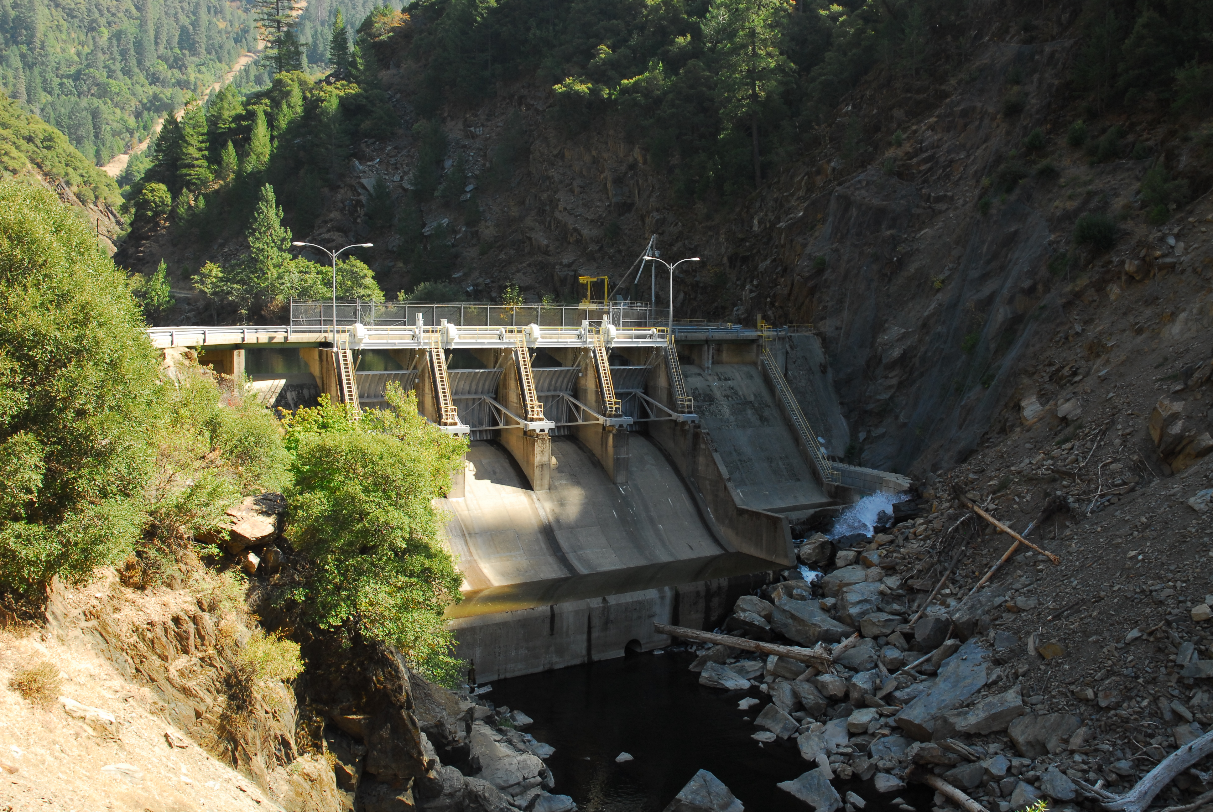
Instream Flow Discharge
Low Level Discharge
Low Level Discharge
Middle Fork Interbay Dam
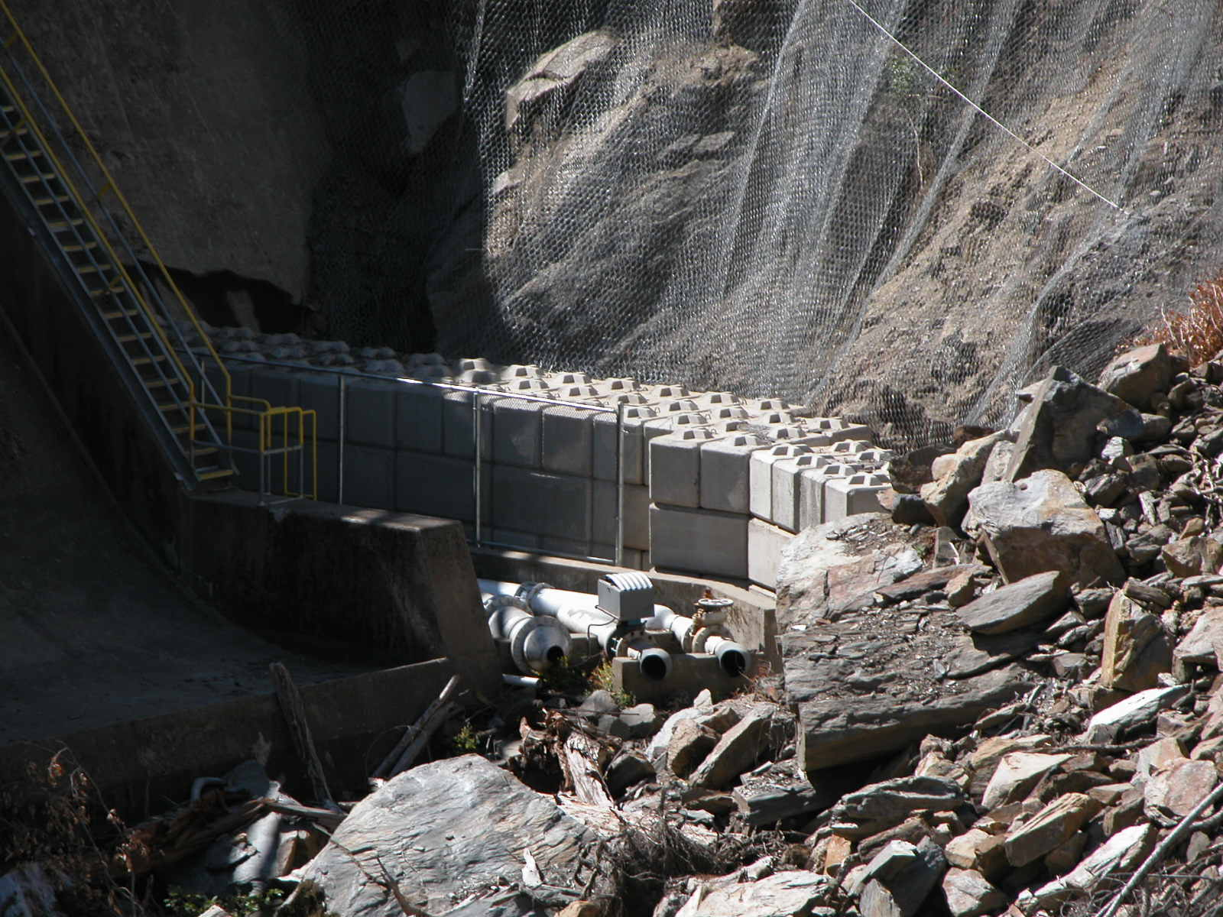
Instream Flow Pipes
Middle Fork Interbay Dam - Instream Flow Pipes
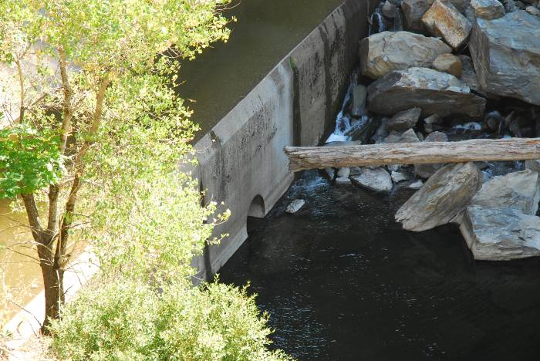 | 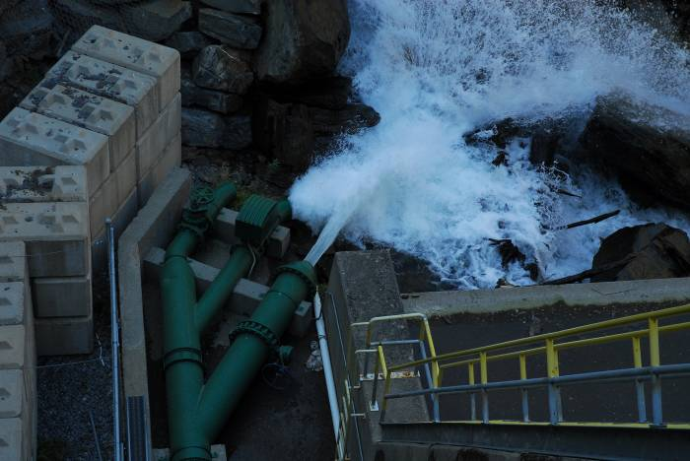
Interbay Dam Low Level Discharge | Instream Flow Pipes
Middle Fork Interbay

Middle Fork Powerhouse Photograph

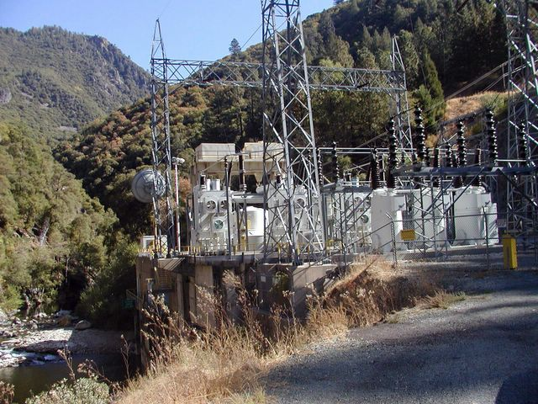
Middle Fork Powerhouse
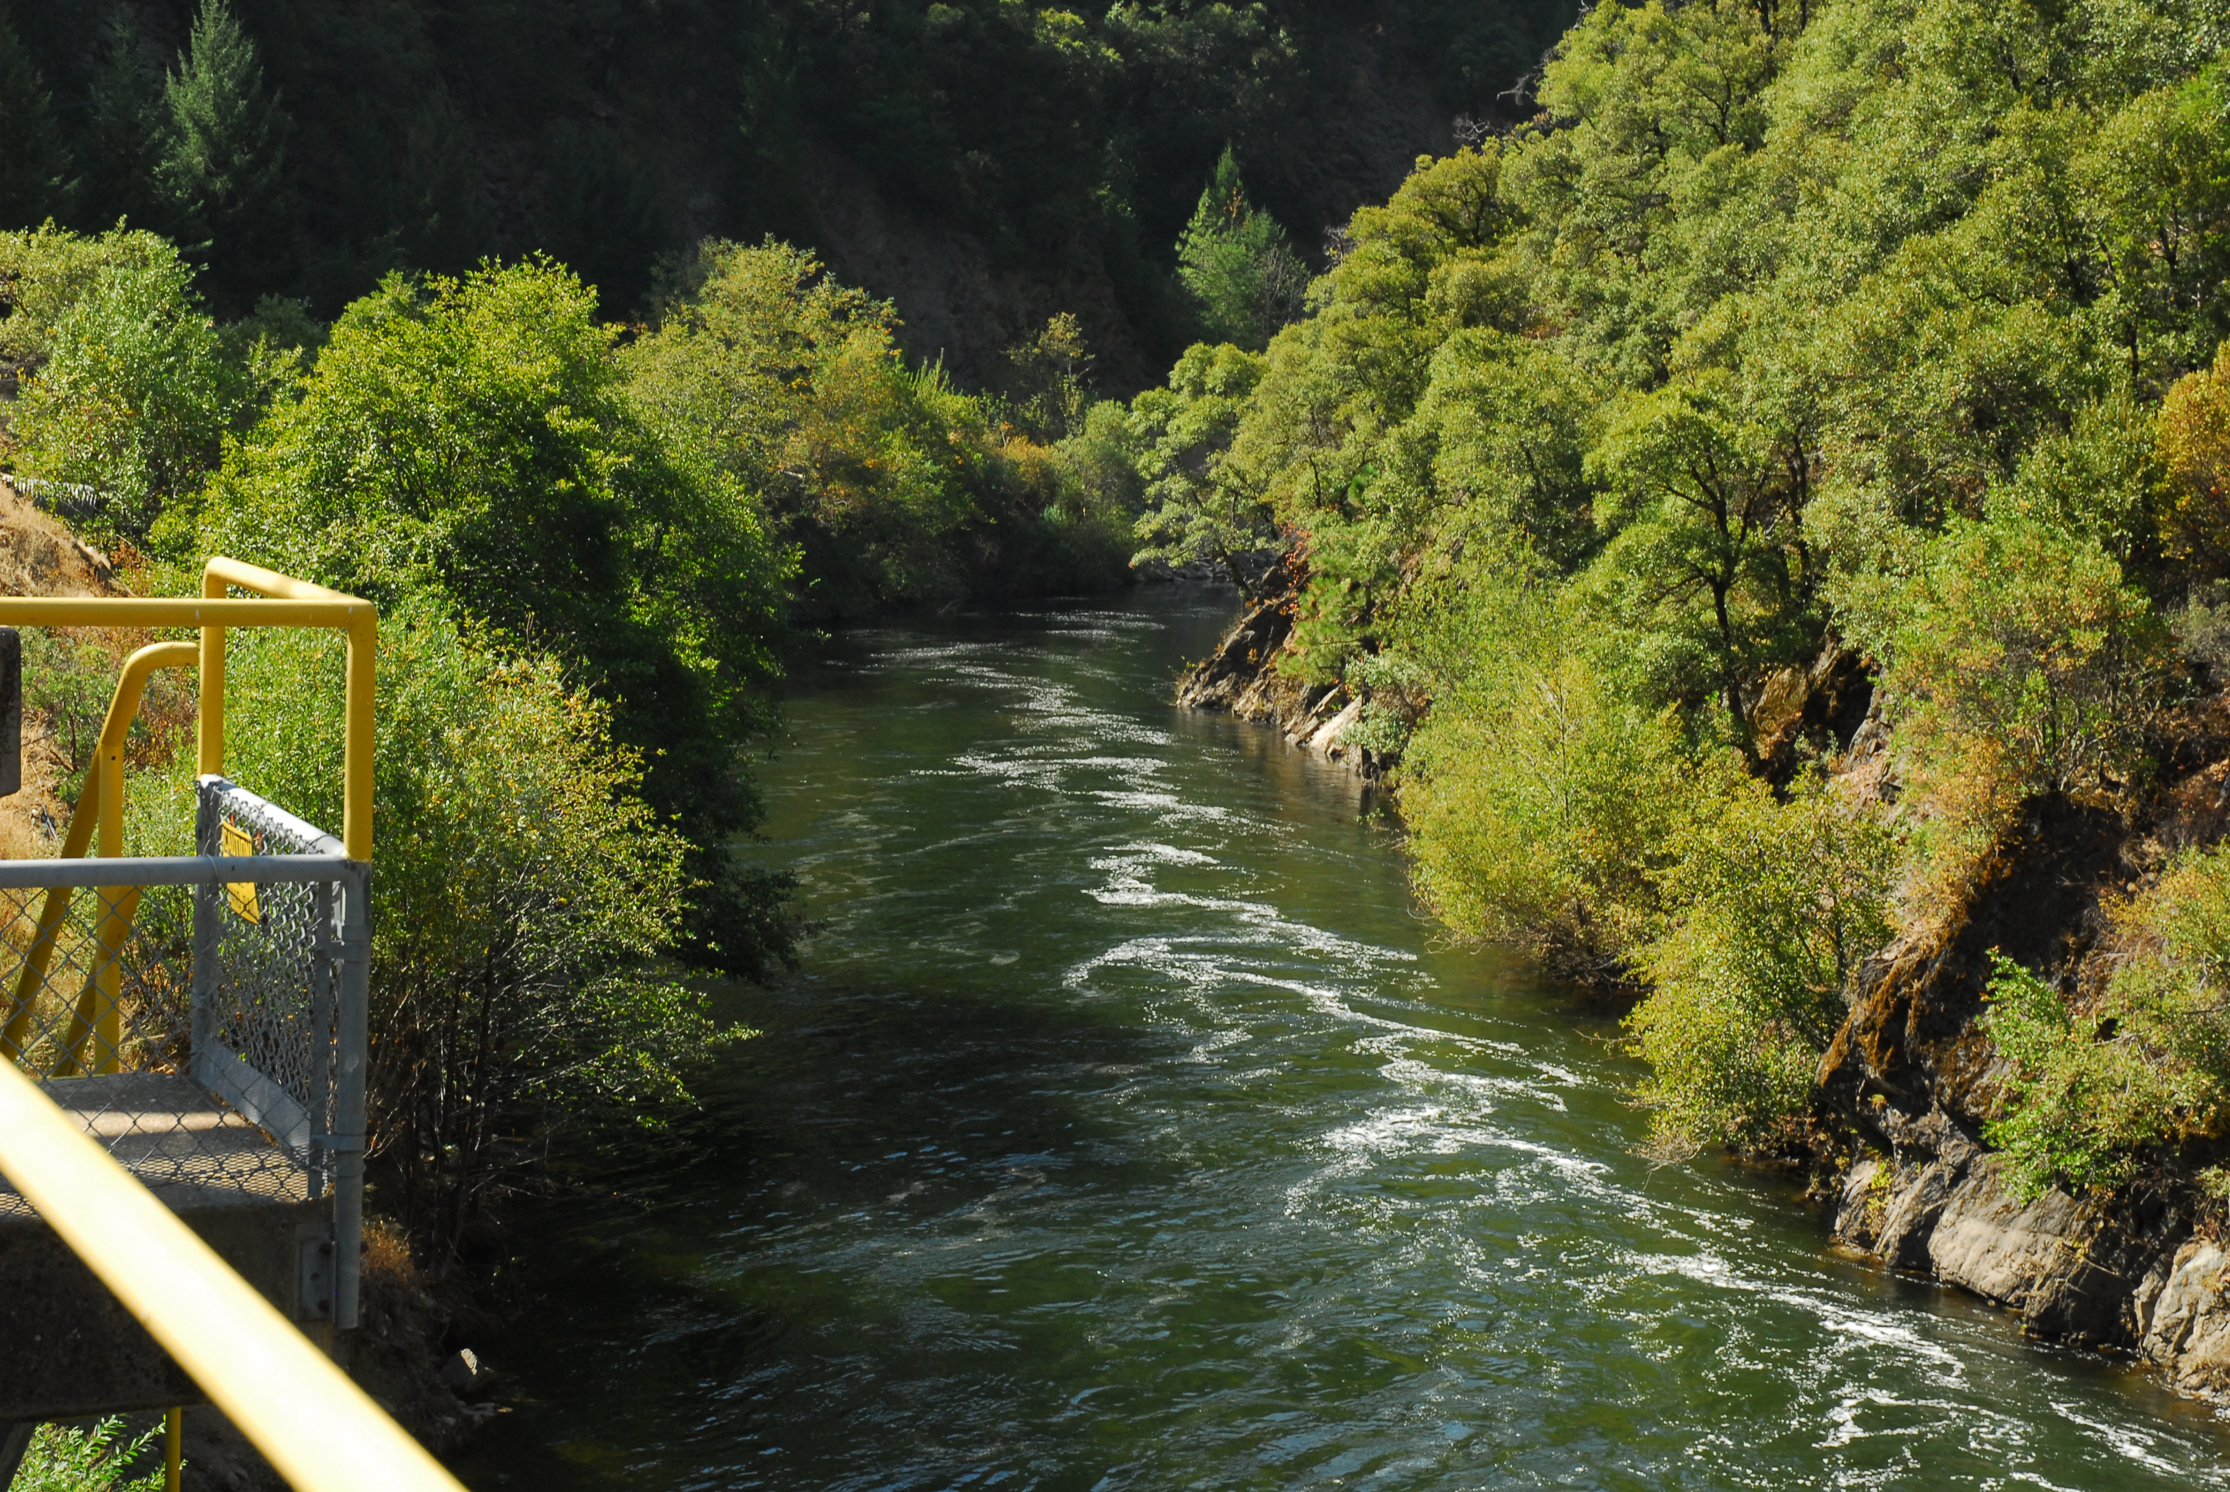
Middle Fork Interbay below Powerhouse
French Meadows Reservoir

French Meadows Dam Outlet Works Photographs
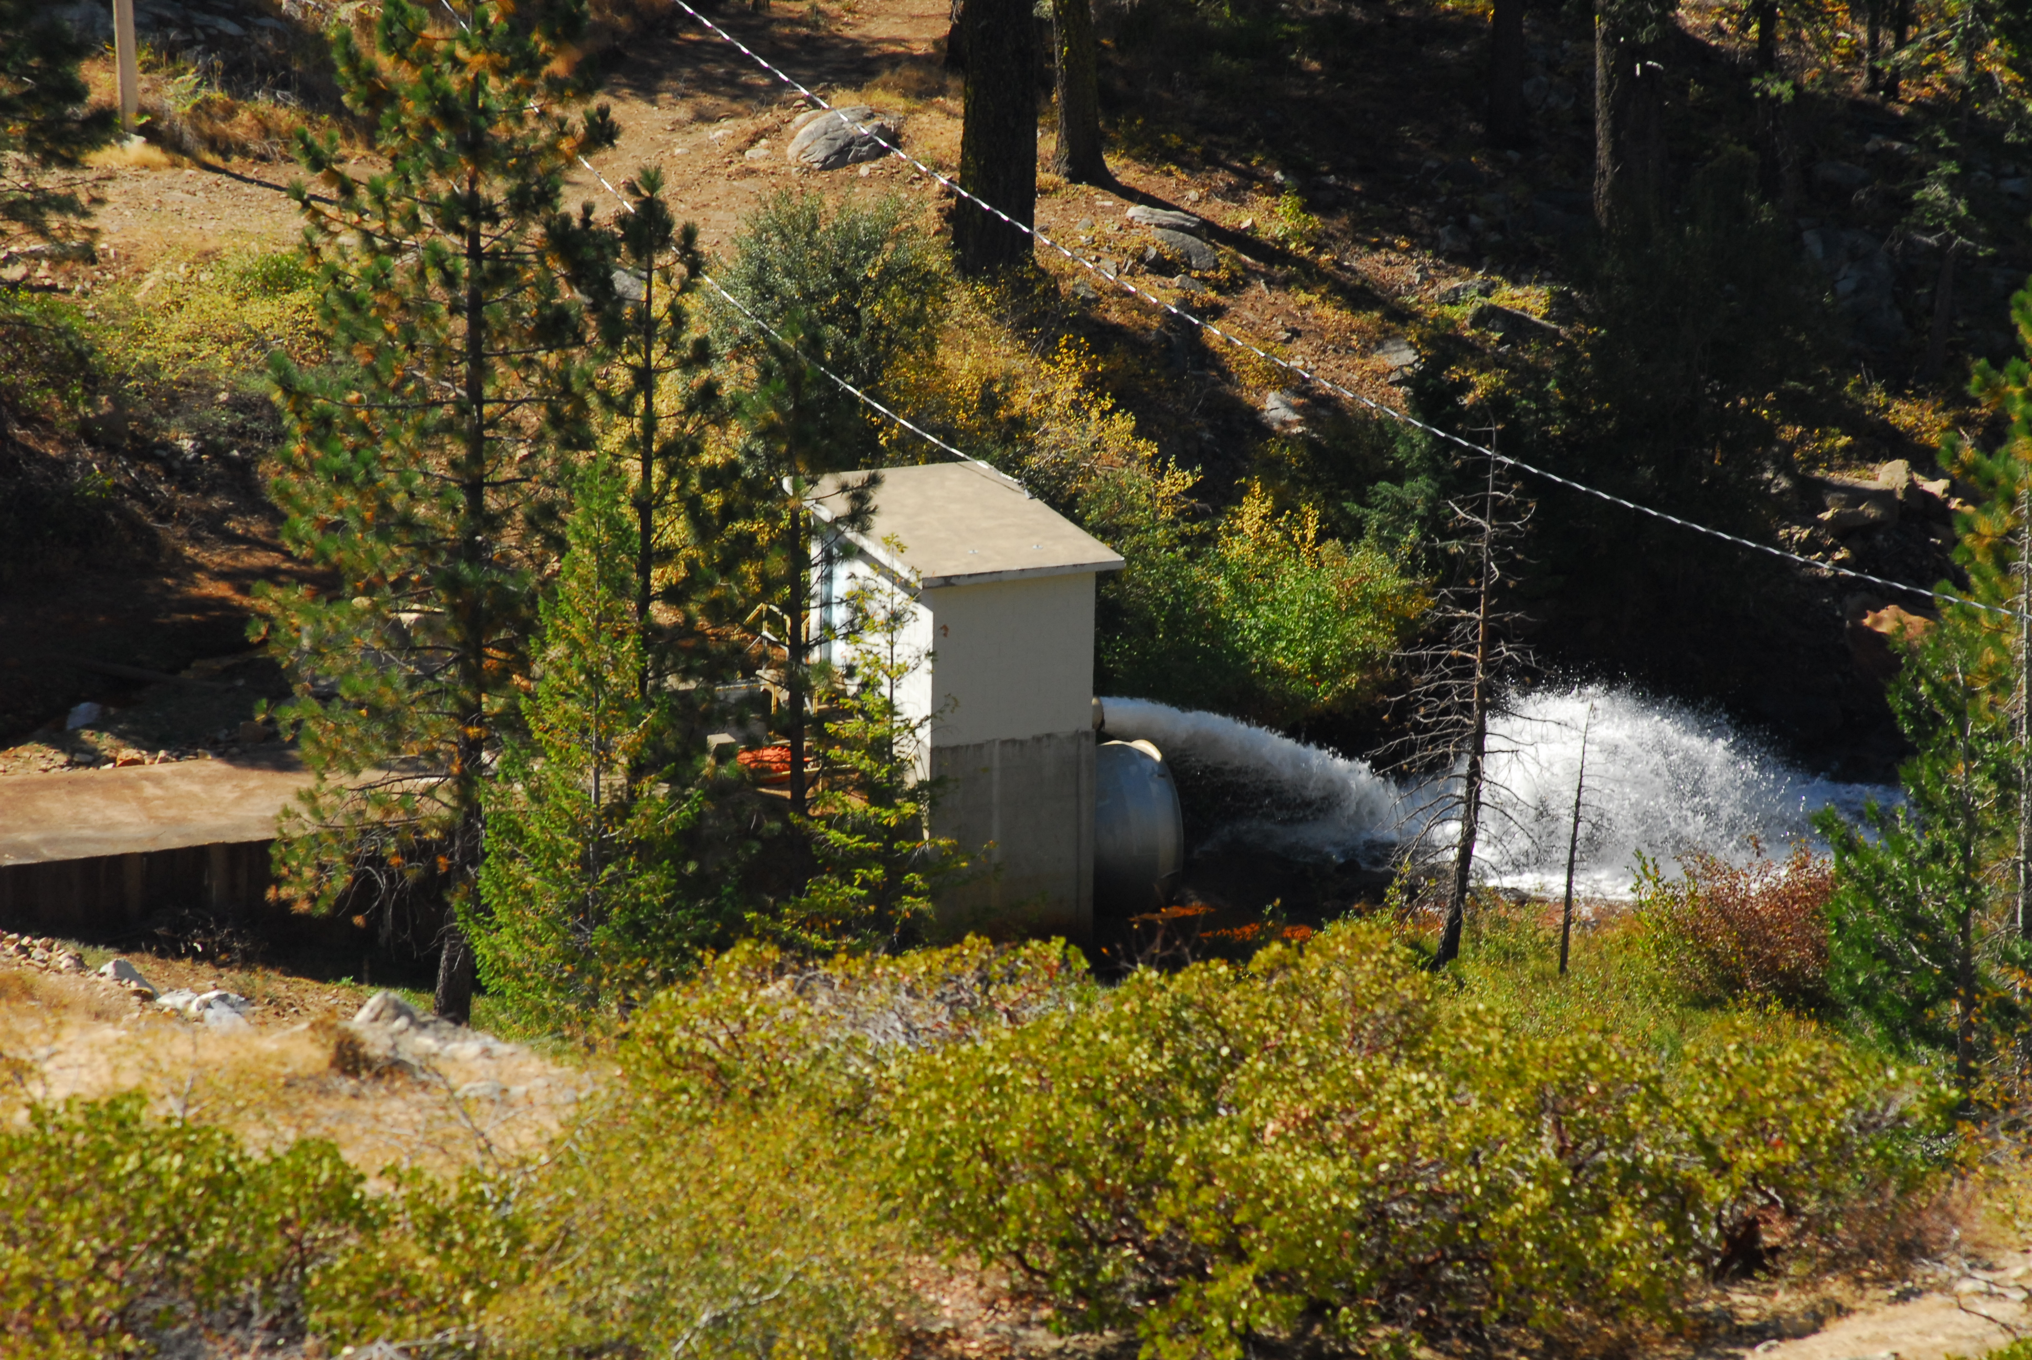

French Meadows Outlet Works

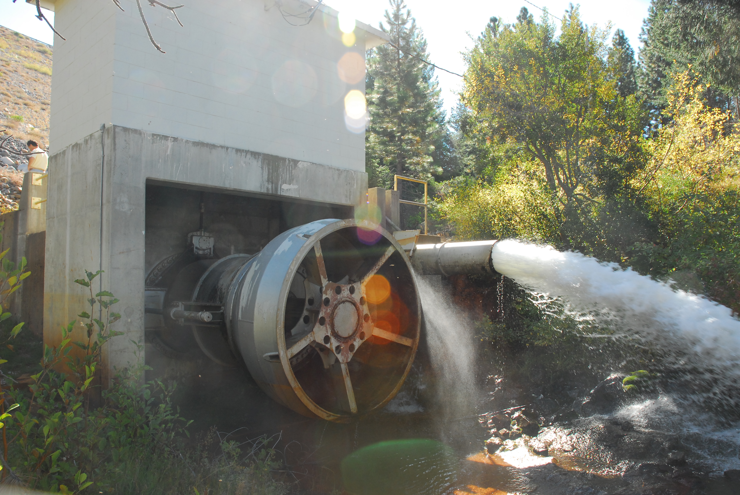

Instream Flow Pipe

Low Level Outlet - Ring Jet Valve

French Meadows Outlet Works - Instream Flow Pipe and Low Level Outlet
French Meadows Reservoir

French Meadows - Hell Hole Tunnel Intake Photograph

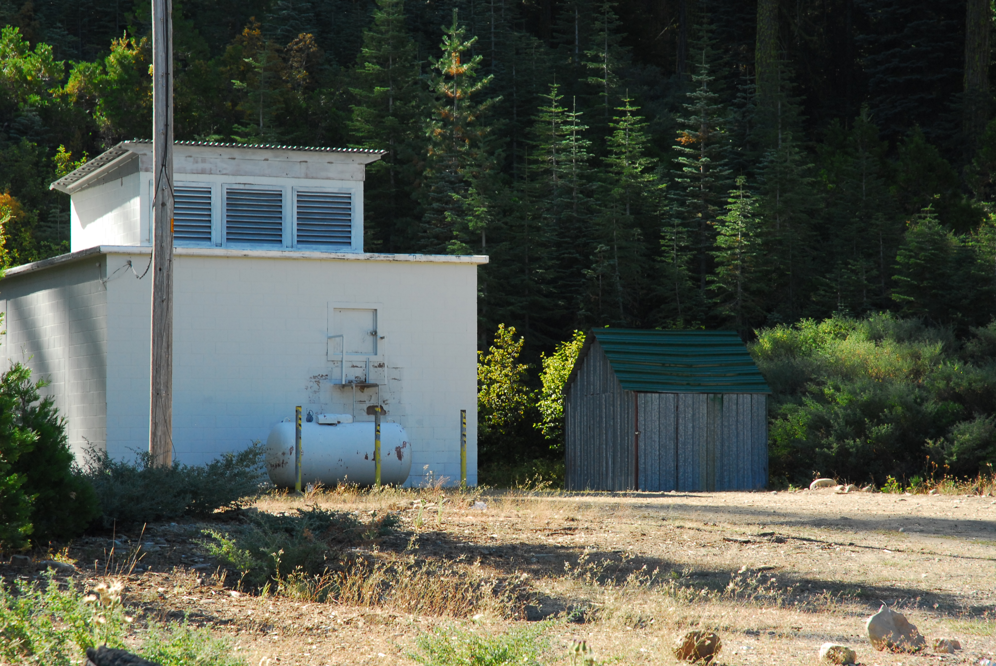
French Meadows - Hell Hole Tunnel Inlet Gatehouse
Hell Hole Reservoir

French Meadows Powerhouse Photograph

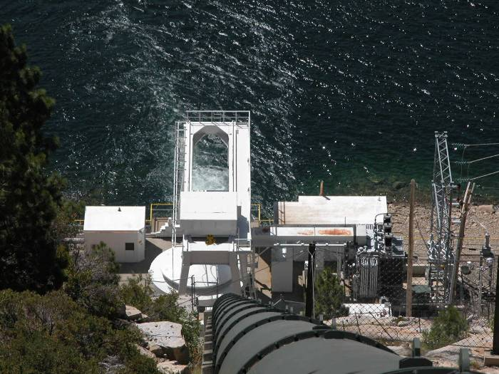
French Meadows Powerhouse

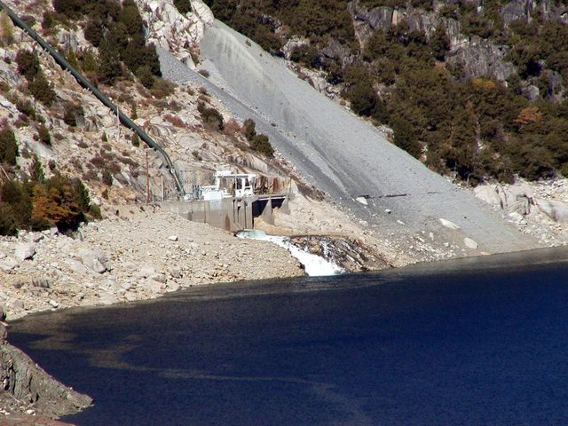
French Meadows Powerhouse
Hell Hole Reservoir

Hell Hole Dam Outlet Works Photographs

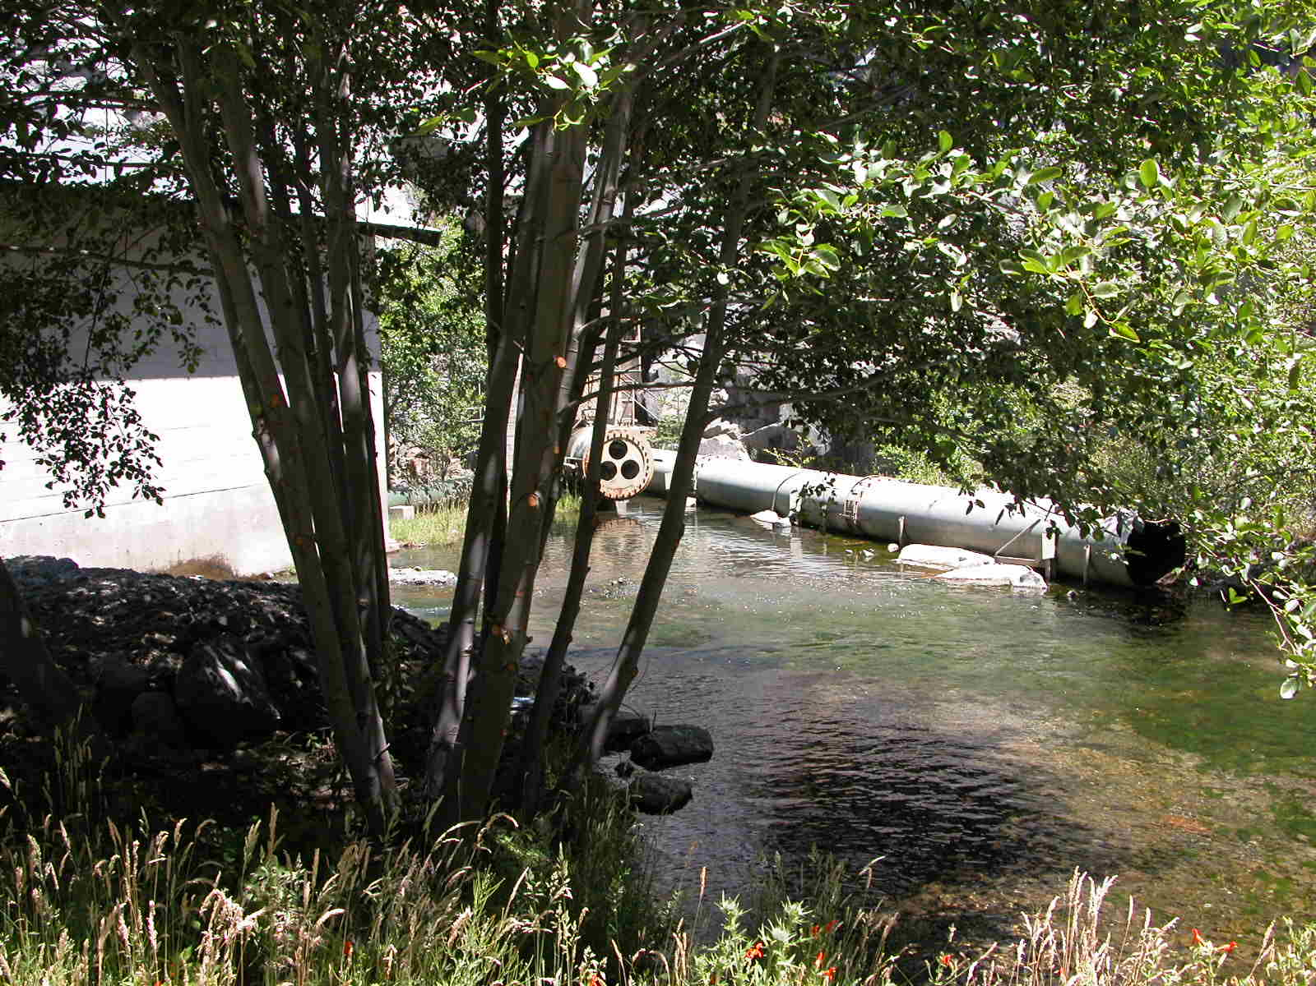
Power House Outlet
Low Level Outlet with Ring Jet Valve
Instream Flow Pipe
Dam Outlet Works

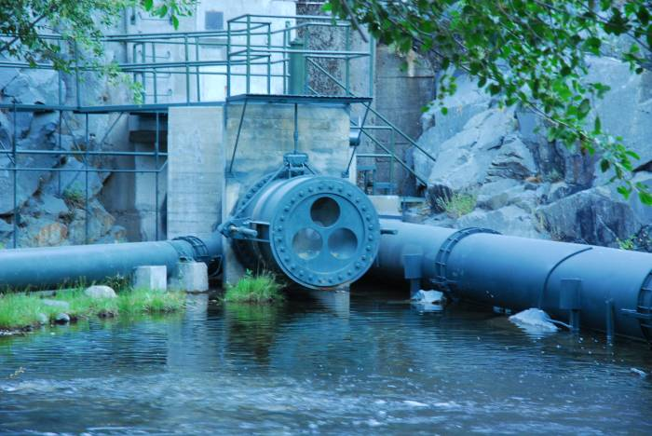
Dam Low Level Discharge Ring Jet Valve
Hell Hole Reservoir

Hell Hole - Middle Fork Tunnel Intake Photograph

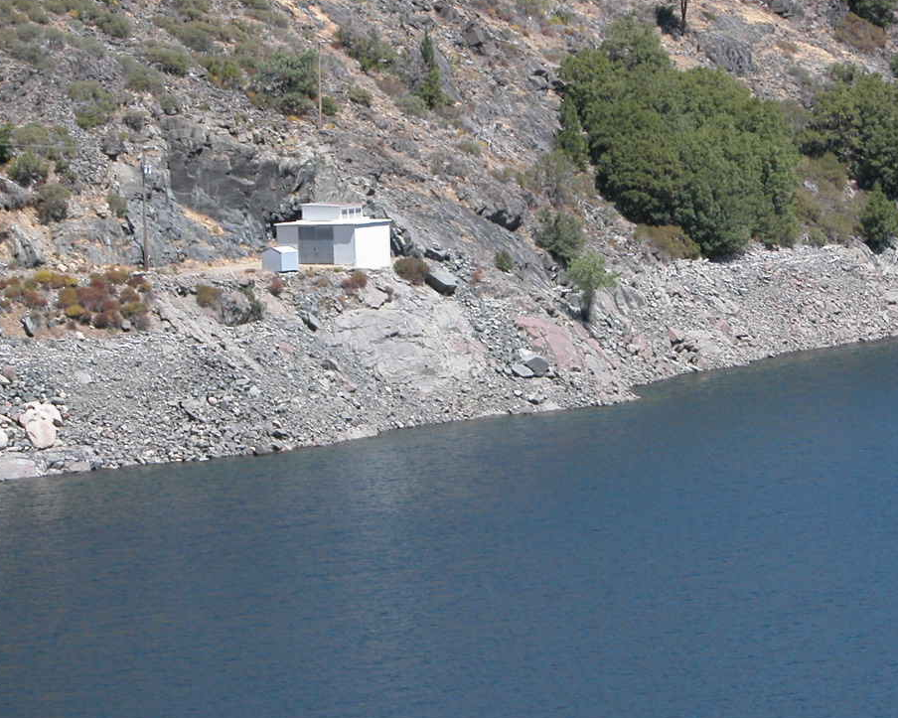

Hell Hole - Middle Fork Tunnel Intake Gatehouse

North Fork Long Canyon

North Fork Long Canyon Diversion Dam Photographs
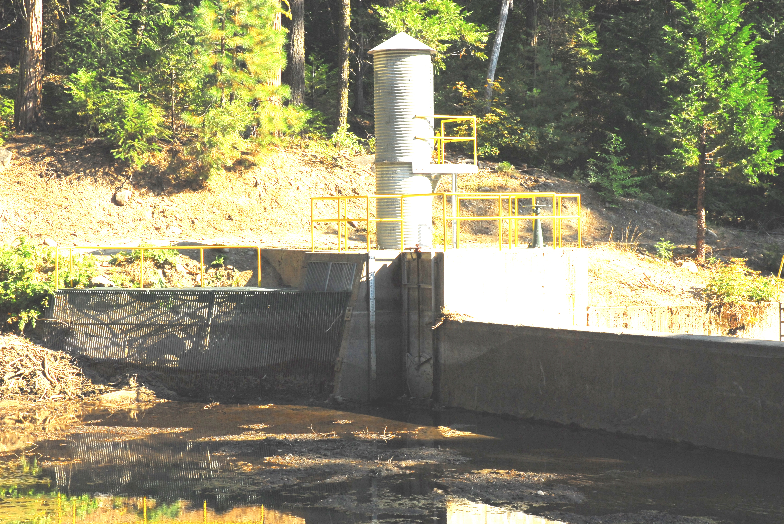

Low Level Outlet
Diversion Inlet

North Fork Long Canyon Diversion - Downstream Side

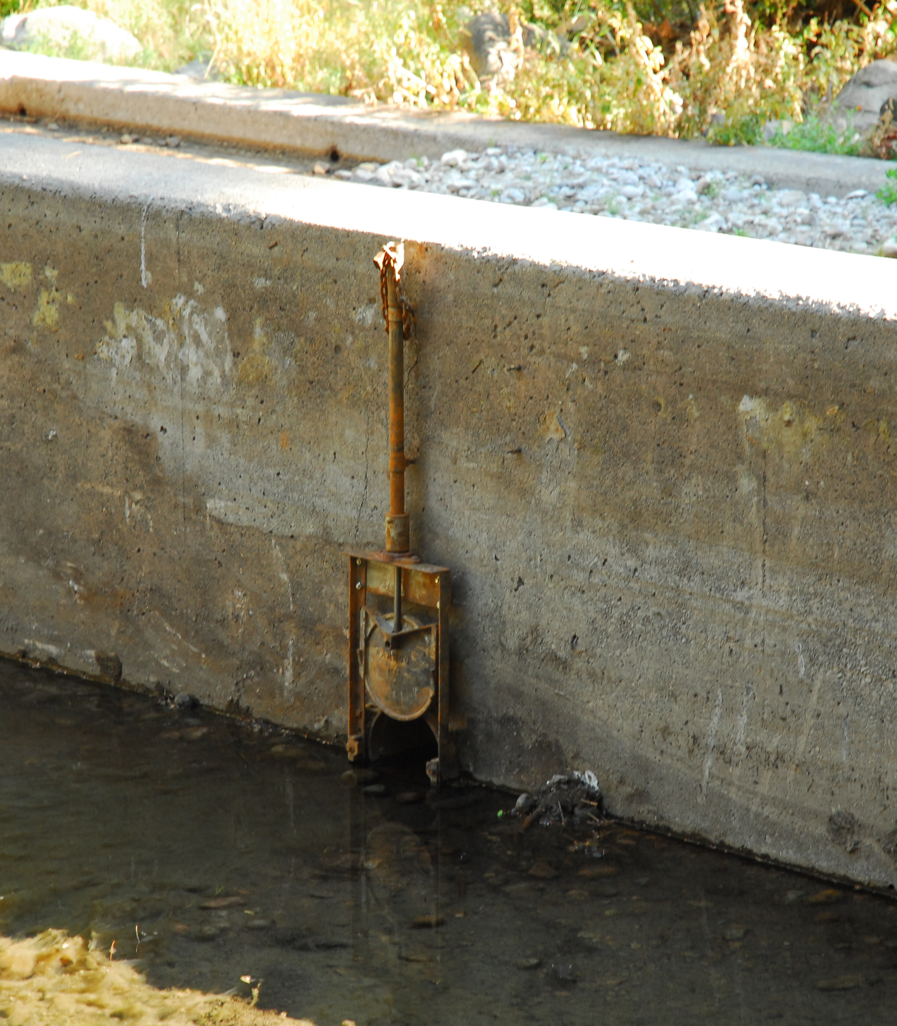

North Fork Long Canyon Diversion - Instream Flow Pipe

South Fork Long Canyon

South Fork Long Canyon Diversion Dam Photographs

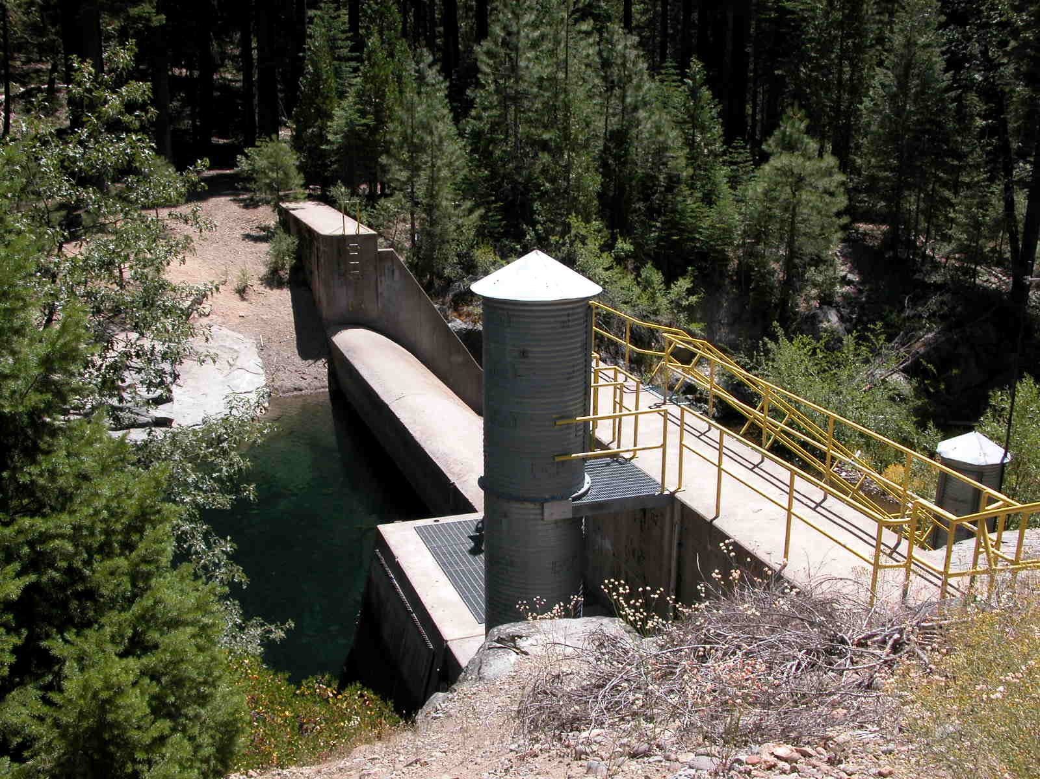

Instream Flow Pipe

Low Level Outlet

Diversion and Trash Rack

South Fork Long Canyon Diversion Dam
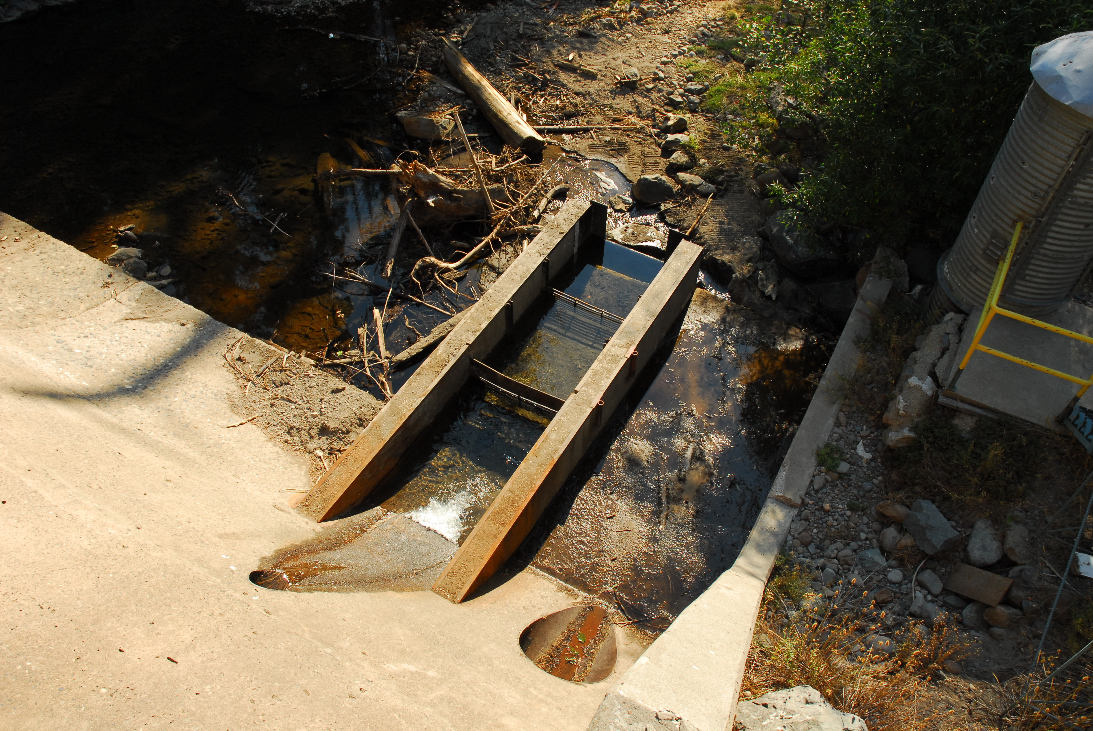

Instream Flow Pipe

Low Level Outlet

South Fork Long Canyon Diversion Dam - Downstream Side

Duncan Creek

Duncan Creek Diversion Dam Photographs
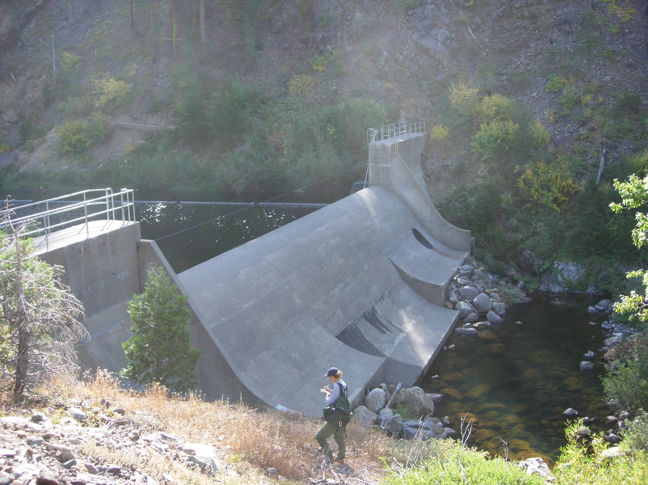

Low Level Discharge

Duncan Creek Diversion Dam - Downstream Side

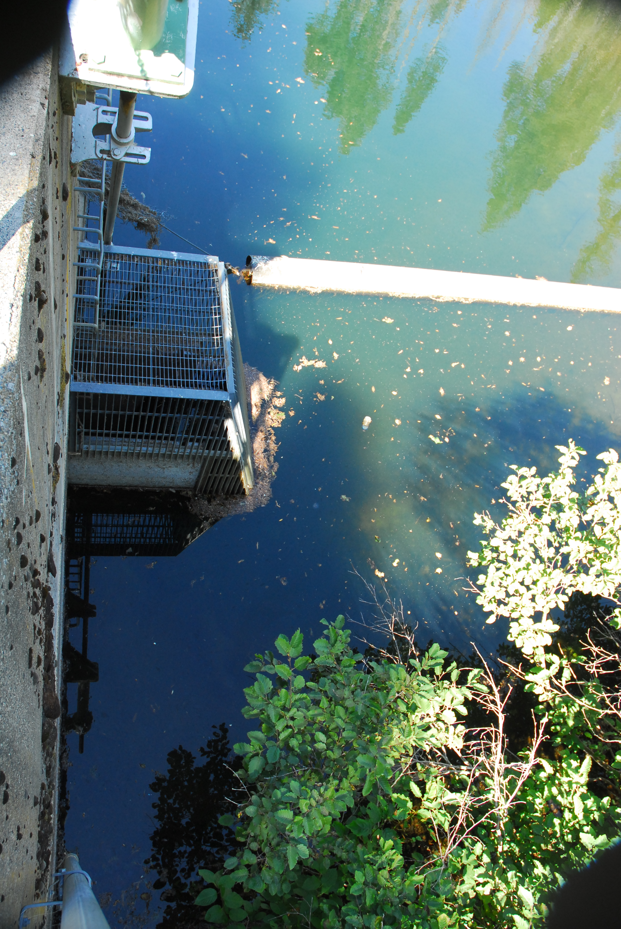

Inlet to Upstream Flow Pipe

Duncan Creek

Duncan Creek - Middle Fork Intake and Trash Rack Photograph

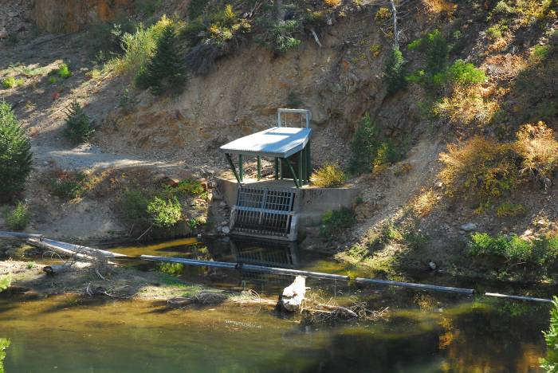
Duncan Creek - Middle Fork Tunnel Intake

